Eyeconic - Glasses Shop Management System

Category

Version 1.0

Revision History

|  |  |  |  |
| --- | --- | --- | --- |
| **Date** | **Version** | **Description** | **Author** |
| 20/11/2019 | 1.0 | The first version of remove category | Hoàng Tiến Long |

Table of Contents

1. Introduction 4

1.1 Purpose 4

1.2 Scope 4

1.3 Definitions, Acronyms, and Abbreviations 4

1.4 References 4

1.5 Overview 4

2. Flow of Events—Design 4

3. Derived Requirements 6

# Introduction

## Purpose

This document describes how the Remove Category use case is realized within the design model.

## Scope

This document applies to the Eyeconic - Glasses Shop Management System.

## Definitions, Acronyms, and Abbreviations

None.

## References

None.

## Overview

In the following section, Use-Case Realization Specification of the Remove Category use-case of the Eyeconic is provided in detail. The first section is a textual description of the Use-Case specification. The following section contains sequence diagrams describing how the use case is realized in terms of collaborating objects. The third section includes class diagrams with relationships that participate in the realization of the use case. The last section is an analysis of all requirements, such as non-functional requirements, on the use-case realization that are not considered in the design model, but that need to be taken care of during implementation.

# Flow of Events—Design

**2.1. Use-Case Specification**

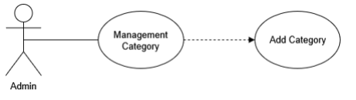

|  |  |  |  |
| --- | --- | --- | --- |
| **Name** | | | Remove Category |
| **Brief Dexcription** | | | Administrator removes new categories into the website. |
| **Actors** | | | Administrator |
| **Flow of Events** | | | |
| **Basic Flow** | | | |
| Step 1: Click the remove category button in category management.  Step 2: Confirm to delete the category.  Step 3: System displays category management in the website. | | | |
| **Alternative Flows** | | | |
| **Title** | | **Description** | |
| Invalid information entered | | 1. System displays information with appropriate message to correct invalid information. | |
| **Pre-Conditions** | | | |
| None. | | | |
| **Post-Condition**  Administrator checks the database and the website to ensure that the new category is removed successfully. | | | |
| **Title** | **Description** | | |
| Success | Success message is prompted and the category is removed to database. | | |
| Failure | The admin is unable to remove new category to database for one or more reasons and an error is prompt. | | |
| **Extension Points** | None | | |

**2.2. Sequence Diagram**

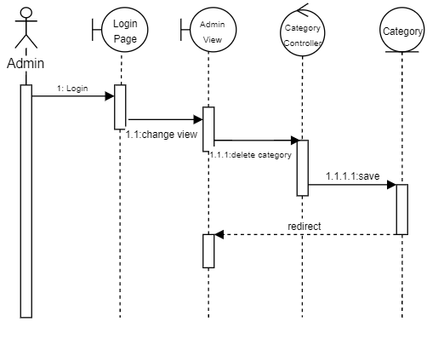

**2.3. Class Diagram**

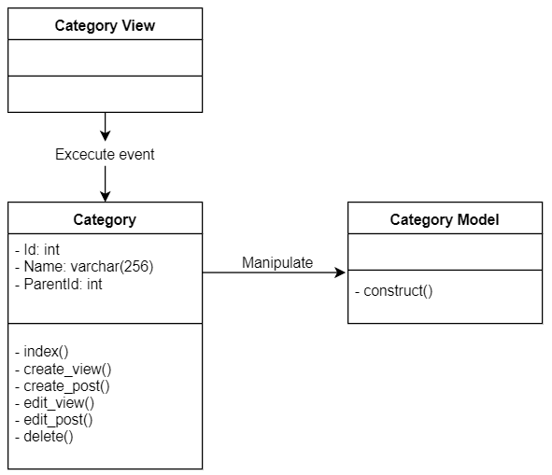

# Derived Requirements

None.